
THE CHINESE UNIVERSITY

OF HONG KONG (SHENZHEN)

School of Science and Engineering

Tutorial - 3

Fundamental of Artificial Intelligence CSC3180

- Answer the following questions:

- In Lecture 4, we have learned from best-first search → greedy best-first search → A* search. Please compare their differences.
- How to understand the heuristic functions of 8-puzzle, h1 and h2? (L4: P22-23)
- What relationship between heuristic functions, h1 and h2? (L4: P25-26)
- What is an admissible heuristic? (L4: P20)
- How to generate admissible heuristic functions? (L4: P28-30)
- What is a local maxima? (L4: P39)

- Three functions, including g(n) in Lecture 3 and both f(n) and h(n) in Lecture 4, have been defined to evaluate the search algorithms. Please explain their difference.

- Informed search uses only best-first search. Please understand the following example about its search path and cost.
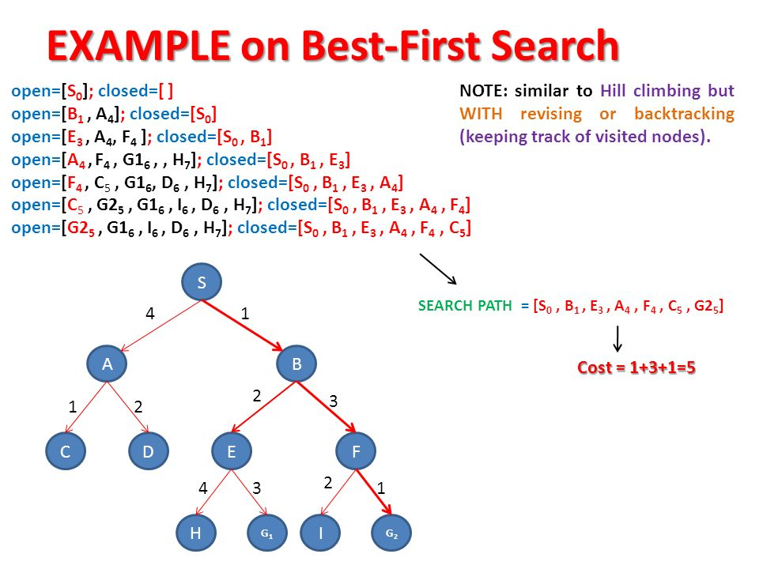

- Consider a search tree with the cost of every step exceeds some small positive constant ε. Check the completeness and optimality of the following search algorithms with T(true) and F(false). What are the conditions for the optimality of BFS, IDS and A*S?
 | BFS | UCS | DFS | IDS | GBFS | A*S
Completeness
Optimality | T’ |  |  | T’ |  | T’
BFS: breadth-first search; UCS: uniform-cost search; DFS: depth-first search; IDS: iterative deepening search; GBFS: greedy best-first search; A*S: A* search; T’: true, subject to some condition.
- Use A* search to search the following graph (S: starting state, G: goal state). h(n) is the estimated distance to the goal. What is the order of the expanded nodes? (L4: P15)
 | S | A | B | C | D | E | F | G
h(n) | 10 | 5 | 8 | 1 | 4 | 2 | 3 | 0
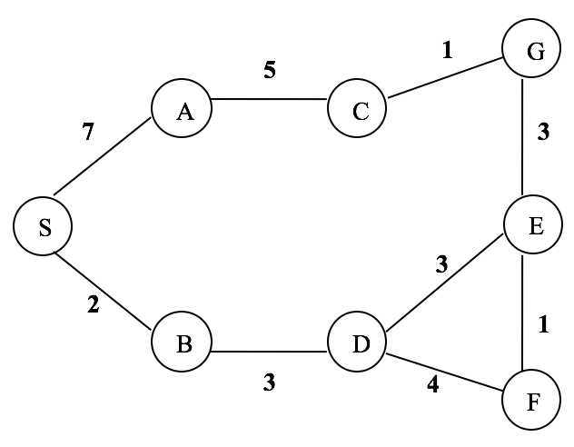

- Use genetic algorithm to solve the 4-queens problem. Suppose two of the initial population are A(3143) and B(1342). The definition of the fitness function is: the number of non-attacking pairs of queens.
(a) Calculate the fitness of A and B.
(b) If A and B is a pair to be mated and the crossover point is after the first digit, what are the offspring (A’ and B’) after crossover?
(c) What is the mutation result if the last digits of both A’ and B’ are mutated to the value of 1?
